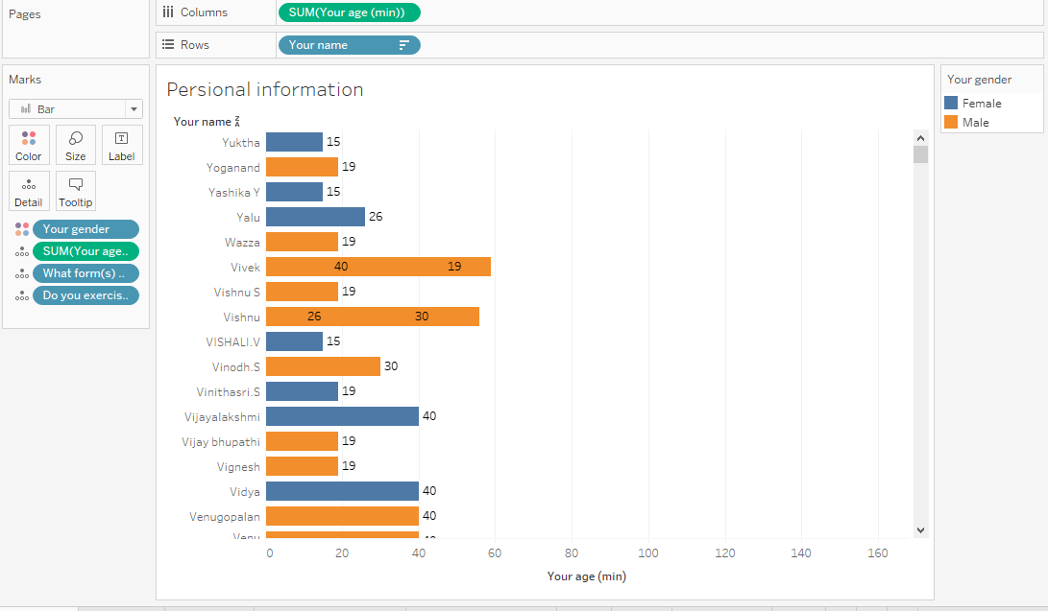

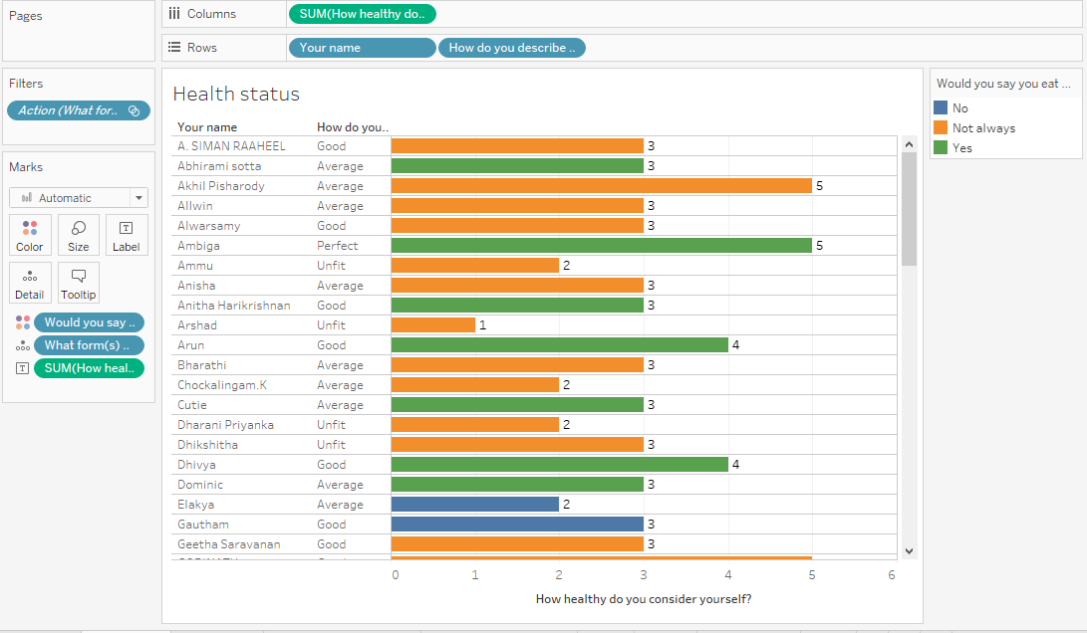

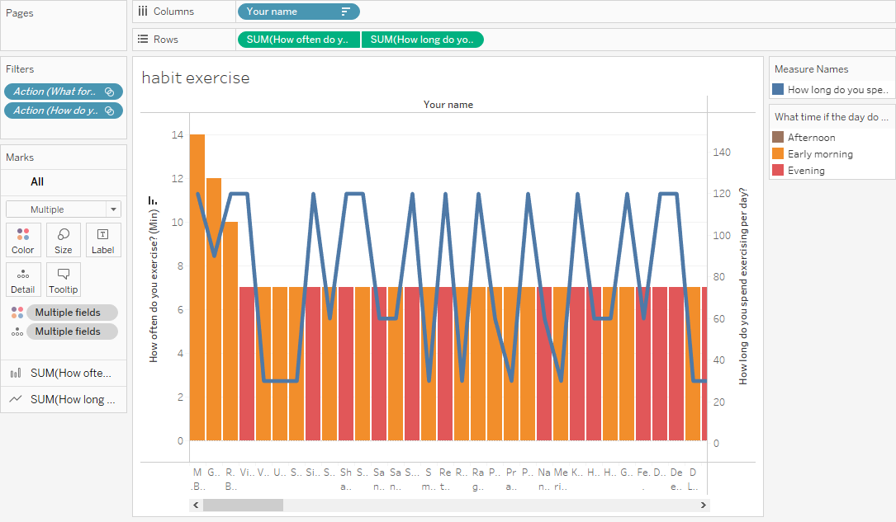

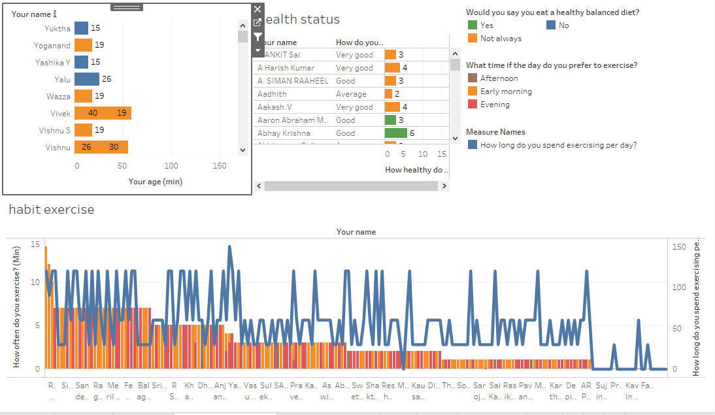

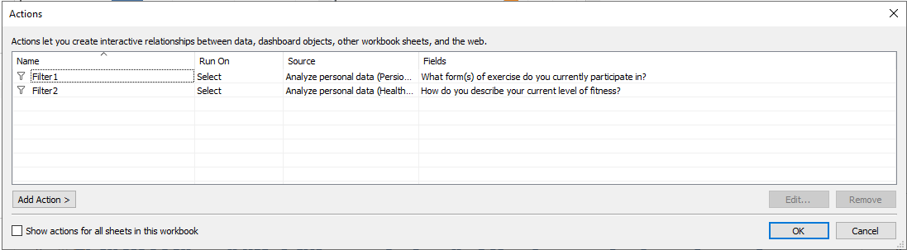

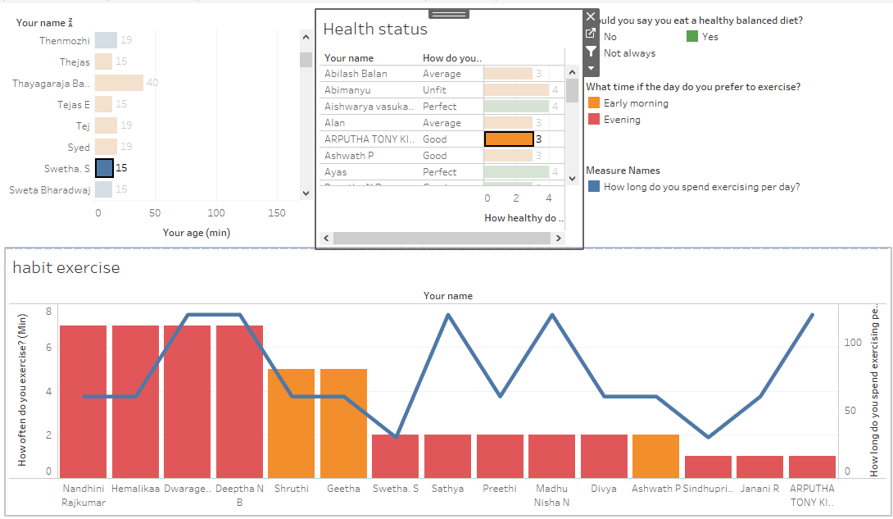

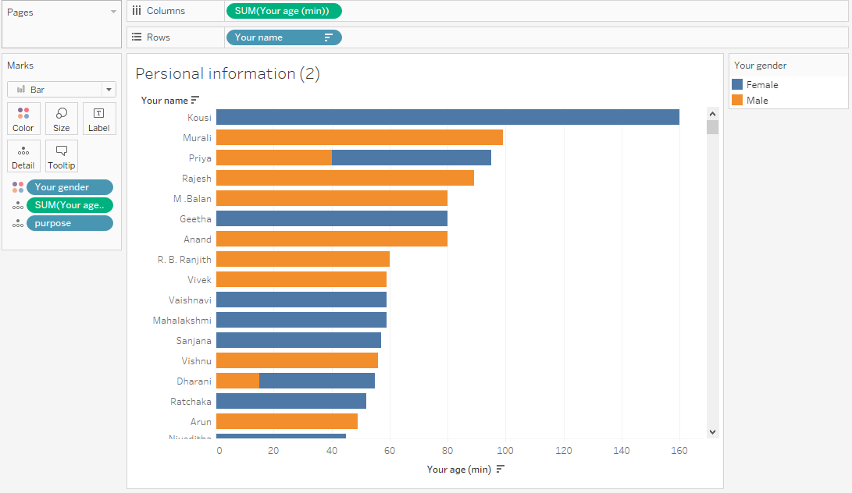

The personal information table (2) will store the information of users including: name, max age, min age, gender and purpose of customers with the following attributes:

[Your name]

[Your gender]

[Your age (min)]

[Your age (max)]

[purpose]: filtered by code

if CONTAINS([What motivates you to exercise?], 'I want to be flexible') then "I want to be flexible" ELSEIF CONTAINS([What motivates you to exercise?], 'I want to relieve stress') then "I want to relieve stress"

ELSEIF CONTAINS([What motivates you to exercise?], 'I want to lose weight') then "I want to lose weight"

ELSEIF CONTAINS([What motivates you to exercise?], 'I want to achieve a sporting goal') then "I want to achieve a sporting goal"

ELSEIF CONTAINS([What motivates you to exercise?], 'I want to be fit') then "I want to be fit"

End

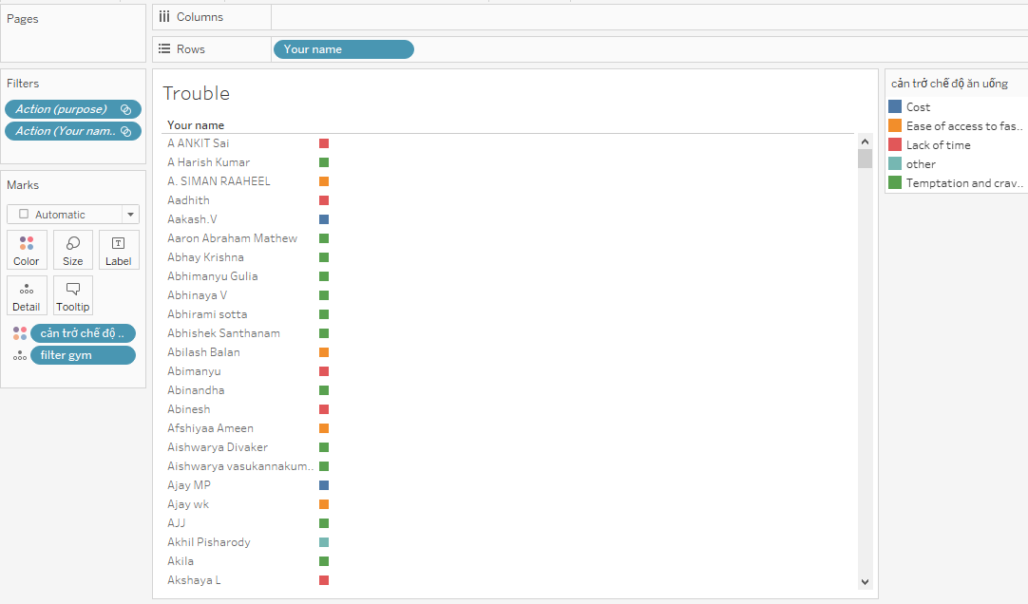

The Trouble table is a table that outlines a client's goals and the obstacles they encounter. [Your name]

[Purpose]

[Trouble]: filtered by code

if CONTAINS([What prevents you from eating a healthy balanced diet, If any?], 'Temptation and cravings') then "Temptation and cravings" ELSEIF CONTAINS([What prevents you from eating a healthy balanced diet, If any?], 'Ease of access to fast food') then "Ease of access to fast food"

ELSEIF CONTAINS([What prevents you from eating a healthy balanced diet, If any?], 'Cost') then "Cost"

ELSEIF CONTAINS([What prevents you from eating a healthy balanced diet, If any?], 'Lack of time') then "Lack of time"

else "other"

end

[filter gym]: filtered by code

if CONTAINS([What form(s) of exercise do you currently participate in?], 'Gym') then "Gym" else "Other"

end

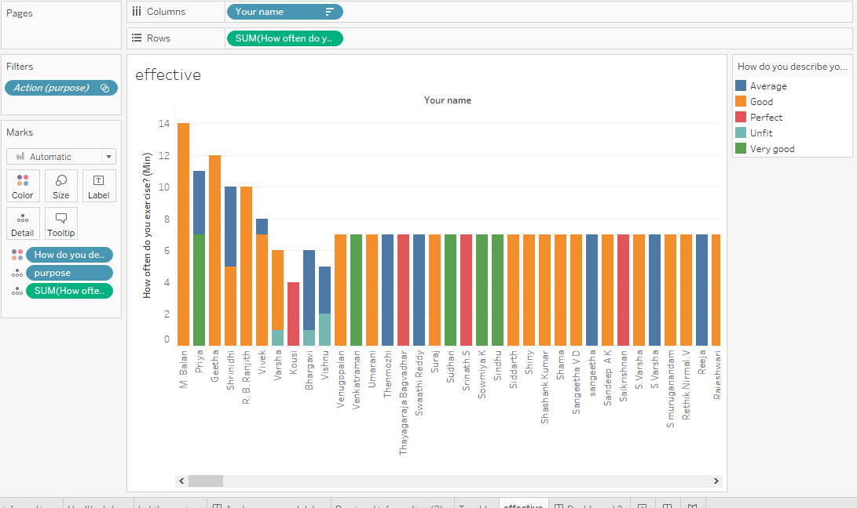

The effective table shows the results of practice of customers:

[Your name]

[How often do you exercise? (Min)]

[How often do you exercise? (Max)]

[How do you describe your current level of fitness?]

[purpose]

Then, merge the 3 sheets above to form a Dashboard. Its meaning is to support clients who practice long and do not perform well. Since then create a good relationship with customers.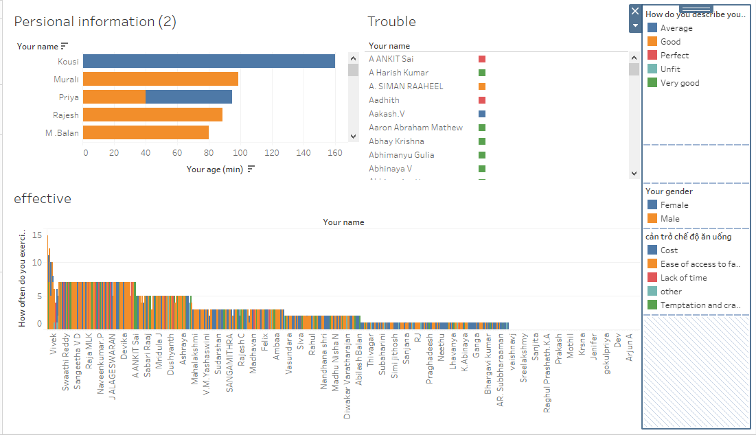

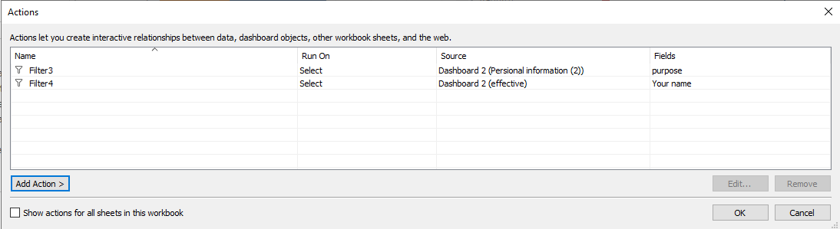

The Personal information table (2) is linked to the effective table via the [Purpose] field.

The effective table binds to the Trouble table via field [Your name]

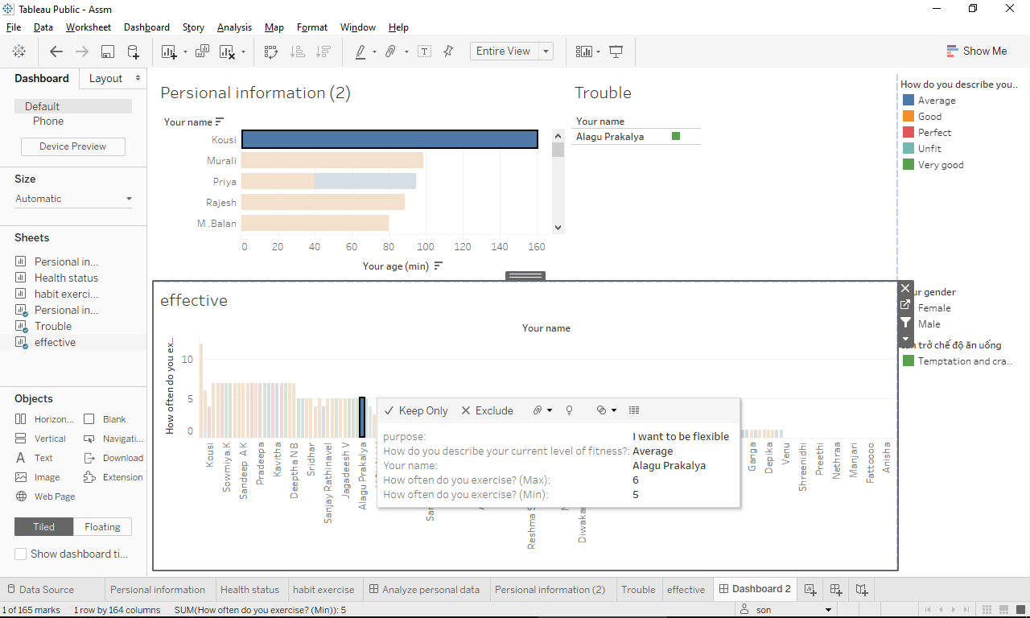

From the Persional information panel (2), choose a training purpose. This will lead to changes to the effective table and the effective table will show practitioners for the chosen purpose: frequency of the practice and its effectiveness.

From there, find out those who practice a lot but are not effective. Selecting that person will change the Trouble panel and show all the obstacles that person is facing.

From there, the company can give people a 1-day free training to solve their problem. It both enhances the training atmosphere and creates good relationships with customers.